**A REPORT ON**

**ATAXIA DISORDER ASSISTIVE TOOL**

SUBMITTED TO THE MUMBAI UNIVERSITY, MUMBAI IN THE PARTIAL FULFILLMENT OF THE REQUIREMENTS FOR THE AWARD OF THE DEGREE

OF

# BACHELOR OF ENGINEERING

# (INFORMATION TECHNOLOGY)

SUBMITTED BY

MR. THORAT MANISH SANTOSH.                        120IT1006A​

MR. PAWAR HERSCHEL PRAVIN.                          120IT1108A​

MR. PRAJWAL SANTOSH WAGHCHHOURE​ 120IT1178A

Under the Guidance of

**Prof. Ankit Anand**

**DEPARTMENT OF INFORMATION TECHNOLOGY**

**MGM’S COLLEGE OF ENGINEERING AND TECHNOLOGY**

**KAMOTHE, NAVI MUMBAI - 410 209**

**UNIVERSITY OF MUMBAI**

**(AY 2023-24)**



**CERTIFICATE**

This is to certify that the Project report entitled

“**ATAXIA DISORDER ASSISTIVE TOOL**”

Submitted by

MR. THORAT MANISH SANTOSH.                        120IT1006A​

MR. PAWAR HERSCHEL PRAVIN.                          120IT1108A​

MR. PRAJWAL SANTOSH WAGHCHHOURE​ 120IT1178A

is a bonafide student of this institute and the work has been carried out by him/her under the

supervision of Prof. Ankit Anand and it is approved for the partial fulfillment of the requirement of Mumbai University, for the award of the degree of Bachelor of Engineering (Information Technology).

**Prof. Ankit Anand**

Guide

Department of Information Technology

**Dr. Swati Sinha Dr. Geeta S. Lathkar**

Head Director

Department of Information Technology MGMCET, Navi Mumbai

Place:- Kamothe

Date:-

**PROJECT REPORT APPROVAL**

## This Project entitled “**ATAXIA DISORDER ASSISTIVE TOOL**” by **MR. THORAT MANISH SANTOSH.** (UID- 120IT1006A), **MR. PAWAR HERSCHEL PRAVIN** (UID 120IT1108A) and **MR. PRAJWAL SANTOSH WAGHCHHOURE** (UID- 120IT1178A) is approved for the degree of Bachelor of Engineering in Information Technology.

### 1.……………………………………

External Examiner

**2……………………………**

Internal Examiner

Place: Kamothe

Date:

|  |  |  |  |
| --- | --- | --- | --- |
| **DECLARATION**  We declare that this written submission represents our ideas in our own words and where other’s ideas or words have been included, we have adequately cited and referenced the original sources. We also declare that we have adhered to all principles of academic honesty and have not misrepresented or fabricated or falsified any idea/data/fact/source in our submission. We understand that any violation of the above will be cause for disciplinary action by the institute and can also evoke penal action from the source which has thus not been properly cited or from whom proper permission has not been taken when needed. | | | |
| Sr. no | Name of Student | UID | Signature |
| 1 | Thorat Manish Santosh | 120IT1006A |  |
| 2 | Pawar Herschel Pravin. | 120IT1108A |  |
| 3 | Prajwal Santosh Waghchhoure | 120IT1178A |  |

Place: Kamothe

Date:

**INDEX**

|  |  |  |
| --- | --- | --- |
| **Serial No.** | **Topic** | **Pages** |
| 1 | Introduction | 1 |
| 2 | Abstract | 2 |
| 3 | Problem Statement | 3 |
| 4 | Scope | 4 |
| 5 | Literature Survey | 5 |
| 6 | Feasibility Study | 7 |
| 7 | Existing System | 9 |
| 8 | Proposed System | 10 |
| 9 | Hardware and Software Requirements | 11 |
| 10 | Modules | 12 |
| 11 | System Architecture and Flowchart | 13 |
| 12 | Output and Snapshots | 14 |
| 13 | Conclusion | 16 |
| 14 | References | 17 |

# INTRODUCTION

A webside is an **deep-learning**  application for human interaction with camera mode. It’s developed to communicate the same way as human activity in their chat.

The chatbot is developed by the proper tuning and testing based on **NLU** to make it more adaptable by humans. You must have been using a chatbot in your life from seeking some online product to hunting for pizza at dominos online store.

Some of the common **ML Chatbots** include **Google Assistant, Alexa, Siri, Cortona**, etc. If you own **windows, android phones, or iPhones,** then you must be conscious of these apps.

If you look into the industrial application of chatbot, there are many as many firms who are using it to scale their business at a greater level, as it supports them in managing their relations with customers. Like in **Facebook Messenger, Telegram, Slack, Skype, Twitter, etc**. there are some inbuilt chatbots where users can interact in the same way as humans interact.

While surfing the internet, you might find in some websites an option of "***Chat with us"***, so when you click on that there will be a pop up with some program generated message, which is a chatbot developed by the company **for customer support.**

**ABSTRACT**

* In the realm of healthcare technology, the integration of pose detection libraries, exemplified by PoseNet, has revolutionized the analysis of human movement patterns. This study explores the innovative utilization of PoseNet, a deep learning-based pose detection library, to develop a sophisticated tool for real-time posture analysis. The research focuses on capturing the user's video feed through the device's camera using the getUserMedia API, providing a seamless input source for posture analysis. By integrating PoseNet into the tool, key body points are meticulously analyzed and tracked, frame by frame, allowing for precise posture assessment.
* The study delves into the intricate process of data analysis, involving the calculation of angles between crucial joints—shoulders, hips, knees, and ankles. By focusing on shoulder angles, hip angles, knee angles, and ankle angles, the tool offers comprehensive insights into the user's upper body posture, pelvic alignment, lower limb stability, and foot posture. This granular analysis provides a nuanced understanding of the user's posture, enabling accurate identification of deviations from standard postures associated with Ataxia disorders.
* The research methodology incorporates cutting-edge technology, emphasizing the importance of real-time body point coordinates provided by pose detection libraries. Through meticulous data analysis and mathematical calculations, the tool offers a detailed assessment of the user's posture, paving the way for enhanced diagnostic capabilities. This study showcases the potential of pose detection libraries and their real-time applications in healthcare, underscoring their role in revolutionizing posture analysis and contributing significantly to the field of neurology and rehabilitation. telling jokes or playing games.

**PROBLEM STATEMENT**

In the realm of neurology and rehabilitation, addressing the challenges posed by Ataxia disorders is paramount. Individuals afflicted by Ataxia struggle with coordination, balance, and speech due to neurological impairments, leading to difficulties in maintaining proper posture and unsteady movements. Existing diagnostic methods often lack precision. Hence, there is a pressing need for an advanced web application. This application must seamlessly integrate pose detection technologies like PoseNet, enabling real-time analysis of key body points. By accurately monitoring and analyzing deviations in posture, this tool aims to enhance diagnostic accuracy and therapeutic interventions for individuals suffering from Ataxia disorders. The challenge lies in developing an intuitive, real-time system capable of precise posture analysis, providing timely feedback and aiding in the progression tracking of Ataxia.

***Challenges:***

1. **Real-Time Accuracy:** Ensuring precise real-time detection of body points for immediate analysis.
2. **Variability in Ataxia Symptoms:** Adapting to diverse symptoms and postural deviations in Ataxia patients.
3. **User Experience:** Balancing in-depth analysis with a user-friendly interface for seamless interaction.
4. **Data Privacy and Security:** Safeguarding sensitive user data while utilizing camera feeds for analysis.

**SCOPE OF THE PROJECT**

1. **Comprehensive Ataxia Analysis:** Develop a tool capable of analyzing diverse Ataxia symptoms, accommodating variations in posture deviations, and providing tailored feedback to users.
2. **Real-Time Pose Detection:** Implement PoseNet for accurate real-time tracking of key body points, ensuring immediate and precise analysis of user posture during movement.
3. **Advanced Data Analysis:** Incorporate algorithms to calculate and interpret angles between joints (shoulders, hips, knees, ankles), enabling in-depth assessment of posture and movement patterns associated with Ataxia.
4. **Intuitive User Interface:** Design a user-friendly interface allowing easy initiation and termination of posture analysis, ensuring accessibility for users of varying technical backgrounds.
5. **Customizable Alert System:** Implement an alert mechanism triggered by significant deviations from standard postures, ensuring timely notifications for users and healthcare providers, enhancing intervention possibilities.
6. **Data Security Measures:** Integrate robust data privacy protocols to protect user information, adhering to ethical standards and regulations, instilling confidence in users regarding the security of their health data.
7. **Cross-Platform Compatibility:** Ensure the tool is compatible across various devices and platforms, including smartphones, tablets, and computers, enhancing its accessibility and usability for a broader user base.
8. **User Education and Engagement:** Develop resources within the tool to educate users about Ataxia, its symptoms, and the importance of posture management, fostering user engagement and empowerment in managing their condition.
9. **Continuous Improvement:** Establish a framework for continuous updates and improvements based on user feedback and emerging technologies, ensuring the tool remains relevant and effective in the dynamic field of healthcare technology.

**LITERATURE SURVEY**

* **TITLE OF PAPER**

Development of Intelligent Telegram Chatbot Using Natural Language Processing

* **AUTHOR**

Teddy Surya Gunawan, Asaad Balla Falelmula Babiker, Nanang Ismail and Mufid Ridlo Effendi

* **METHODOLOGY**

Intelligent chatbots have been gaining interest in the past years due to the advance of artificial intelligence algorithms. As a result, many studies have been conducted on emotional transition and dialog structures. One of the benefits is on the medical applications, in which psychological assessment, clinical counseling, autism diagnostics, and advanced cognitive models could be provided. On the other hand, chatbot knowledge generally comes from a web-based information repository, in which the information is reliable, but it is rather not versatile as it does not contain emotions. The objective of this paper is to develop an intelligent chatbot using natural language processing and Telegram API. First, text processing using Telegram API on Python was developed. Next, emotion recognition was performed on the recorded chats. The appropriate response is then sent to the user. Results showed that our Telegram chatbot could interact smoothly with the users and identify the user's emotions.

* **TITLE OF PAPER**

Chatbot with Dialogflow for FAQ Services in Matana University Library

* **AUTHOR**

Simon Prananta Barus and Evalien Surijati.

* **METHODOLOGY**

Industry 4.0 and the situation of the Corona pandemic encourage the development of chatbots. The Matana university library in Indonesia is facing protocol implementation due to the pandemic, library staff vacancies, and the need to improve 24x7 online services. Therefore, a solution is needed to resolve these kinds of problems. The success of chatbots in the business world and public services is the reason for the adoption of chatbots to overcome these problems. The first phase of chatbot development focuses on Frequently Asked Questions (FAQ). The development model for chatbot applications development uses a prototyping model by utilizing Dialogflow, namely the natural language understanding (NLU) platform. Agents, intents, entities, contexts, events, fulfillment, and integration need to be considered before designing a chatbot conversation. The test results are the chatbot is feasible to be accepted and operated. The variety of phrases entered into the Intent will improve accuracy. However, the accuracy of this chatbot will become lower if the language conveyed uses a lot of abbreviations or local/foreign languages. In a further development, it is necessary to apply the system implementation and system maintenance phases, make chatbot responses not rigid like robots and add other library services such as new member registration, information on book availability, user satisfaction, and so on.

# FEASIBILITY STUDY

A feasibility study is a high-level capsule version of the entire System analysis and Design Process. The study begins by classifying the problem definition. Feasibility is to determine if it’s worth doing. Once an acceptance problem definition has been generated, the analyst develops a logical model of the system. A search for alternatives is analysed carefully. There are 3 parts in feasibility study.

1. Operational Feasibility
2. Technical Feasibility
3. Economical Feasibility

**1) Operational Feasibility:**

Operational feasibility for the Ataxia posture analysis tool involves assessing the practicality and usability of the system in real-world scenarios. Considering the tool's user-friendly design and intuitive interface, users, including medical professionals and patients, can readily operate and interpret the results. It accommodates varying levels of technical expertise, ensuring accessibility for diverse user groups. Additionally, the implementation of real-time feedback mechanisms ensures immediate responses to deviations, enhancing its effectiveness in clinical settings.

**2) Technical Feasibility:**

Technical feasibility evaluates the tool's compatibility with existing technology and its ability to perform the required functions efficiently. Leveraging PoseNet and real-time body point coordinates, the tool demonstrates robust technical feasibility. PoseNet's advanced algorithms enable accurate body point detection, while the integration of getUserMedia API ensures seamless video input from diverse devices. The tool's ability to analyze posture frame by frame showcases its technical prowess, ensuring real-time, precise, and reliable results. Furthermore, regular updates and adaptations can be made to align the system with evolving technological standards, enhancing its long-term technical feasibility.

**3) Economical Feasibility:**

Economical feasibility assesses the financial viability of the tool, considering development costs, potential benefits, and long-term sustainability. The tool's development primarily involves open-source libraries like PoseNet, reducing initial costs significantly. Its potential benefits in medical diagnosis, rehabilitation, and research, especially in the field of Ataxia, make it economically viable. Additionally, the tool's scalable design allows for widespread adoption, maximizing its impact and justifying the initial investment. Continuous monitoring of economic factors and user feedback enables cost-effective improvements, ensuring the tool's long-term economic feasibility and affordability for healthcare institutions and professionals

**EXISTING SYSTEM**

In the realm of Computer Vision and Pattern Recognition, a significant advancement has been made with the research paper titled "Auto-Gait: Automatic Ataxia Risk Assessment with Computer Vision on Gait Task Videos."

This study, conducted by Wasifur Rahman and team, aimed to detect individuals exhibiting ataxia-specific gait characteristics (risk-prediction) and assess the severity of ataxia based on gait (severity-assessment) using computer vision techniques.

They meticulously curated a dataset comprising 155 videos from 89 participants, including controls and individuals diagnosed with or prone to spinocerebellar ataxias (SCAs), captured across multiple medical sites in the United States. Through an innovative computer vision pipeline, the team successfully detected, tracked, and isolated participants, extracting crucial gait features like step width, step length, swing, stability, and speed. Remarkably, their risk-prediction model achieved an accuracy of 83.06% and an F1 score of 80.23%, while the severity-assessment model demonstrated a mean absolute error (MAE) score of 0.6225 and a Pearson's correlation coefficient score of 0.7268. Notably, the models maintained their competitiveness when tested on unseen data sources.

The research uncovered vital insights, associating wider steps, reduced walking speed, and increased instability with higher ataxia severity, aligning with established clinical knowledge. This groundbreaking work paves the way for remote ataxia assessments outside clinical settings, potentially revolutionizing ataxia care accessibility.

**PROPOSED SYSTEM**

The proposed system addresses several drawbacks identified in the existing system and improved it :

1. **Automated Ataxia Detection:** The existing system focuses on gait analysis, providing an automated method for ataxia detection. This is a significant advancement compared to manual diagnosis, reducing human error and ensuring consistency in assessments.
2. **Comprehensive Posture Analysis:** The proposed system incorporates Pose Detection Library, specifically PoseNet, for real-time tracking of key body points. This allows for a more comprehensive analysis, including monitoring joints, shoulders, hips, knees, and ankles. The granular analysis helps in understanding posture-related issues in detail.
3. **Real-time Feedback and Alerts:** The system integrates real-time analysis and feedback mechanisms. It not only visualizes the detected posture but also triggers alerts or visual cues when deviations from standard postures are detected. This immediate feedback enables timely interventions and corrections.
4. **User-Friendly Interface:** The proposed system ensures a user-friendly design, allowing users to easily start and stop the analysis. The intuitive interface enhances user experience, making the tool accessible and usable for both clinicians and patients.
5. **Remote Ataxia Assessment:** By utilizing Pose Detection Libraries and real-time body point coordinates, the proposed system opens avenues for remote ataxia assessments. This addresses accessibility challenges, especially for individuals residing in remote areas, enhancing the reach of ataxia care.
6. **Advanced Data Analysis:** The system performs in-depth data analysis, calculating angles between joints to evaluate posture. This detailed analysis provides nuanced insights, enabling a more accurate assessment of ataxia severity. The focus on specific joint angles allows for a deeper understanding of the patient's condition.
7. **Clinical Knowledge Integration:**Through feature importance analysis, the proposed system aligns detected patterns with established clinical knowledge. This ensures that the system's assessments are in line with existing medical expertise, enhancing the reliability of the results.

**HARDWARE AND SOFTWARE REQUIREMENTS**

* + **HARDWARE REQUIREMENTS**:
  1. **Device with Camera**: The user's device, such as a smartphone, tablet, or computer, must have a built-in camera or an external webcam for capturing the video feed.
  2. **Processor**: A multicore processor (e.g., dual-core, quad-core) to handle real-time video processing and analysis efficiently.
  3. **Memory (RAM):** A minimum of 4GB RAM to ensure smooth performance while running the application and processing video data.
  4. **Storage**: Adequate storage space to store the application and recorded video data. SSD storage can enhance data read/write speeds.
  + **SOFTWARE**
  1. Google Chrome
  2. Visual studio code
  3. Pose-net Api, ML5 Api, P5.JS

**MODULES**

1. **Video Input and Processing:**
   * Develop a module to capture the user's video feed using their device's camera through the getUserMedia API.
   * Process the video stream in real-time, ensuring smooth data flow to the Pose Detection module.
2. **Pose Detection Integration:**
   * Integrate PoseNet or a similar pose detection library into the application to detect key body points.
   * Implement logic to identify and track specific body parts, focusing on shoulders, hips, knees, and ankles.
3. **Data Analysis and Visualization:**
   * Perform real-time data analysis, calculating angles between joints based on the detected body points.
   * Utilize the calculated angles to assess posture deviations and anomalies associated with Ataxia.
   * Visualize the analyzed posture by drawing lines connecting body parts or superimposing a skeleton diagram onto the video feed.
4. **User Interface Enhancement:**
   * Design an intuitive user interface that allows users to easily start or stop the analysis process.
   * Display the live video feed alongside the analyzed posture, highlighting any deviations or abnormalities for user review.
5. **Data Logging and Storage:**
   * Incorporate a data logging system to store the analyzed posture data securely.
   * Implement a database or file storage mechanism to maintain a record of user sessions and analysis results for future reference.
6. **Accessibility and Responsiveness:**
   * Ensure the web application is accessible across various devices and platforms, including smartphones, tablets, and computers.
   * Implement responsive design principles to optimize user experience on different screen sizes.

**SYSTEM ARCHITECTURE**

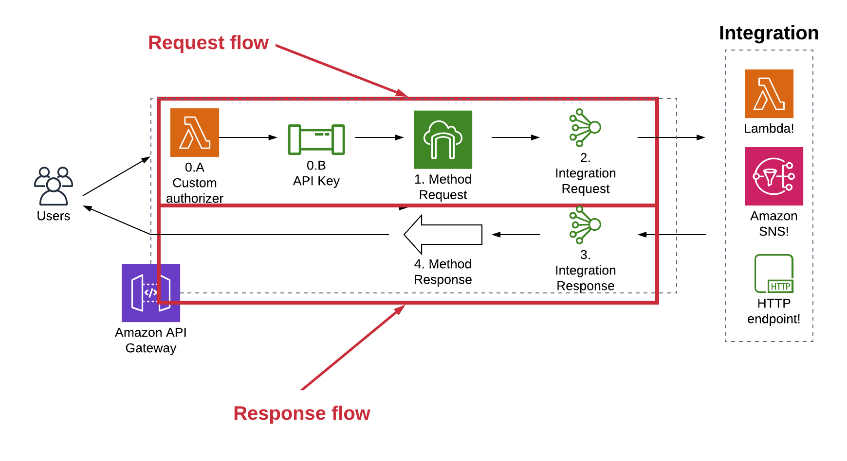

***DATAFLOW DIAGRAM***

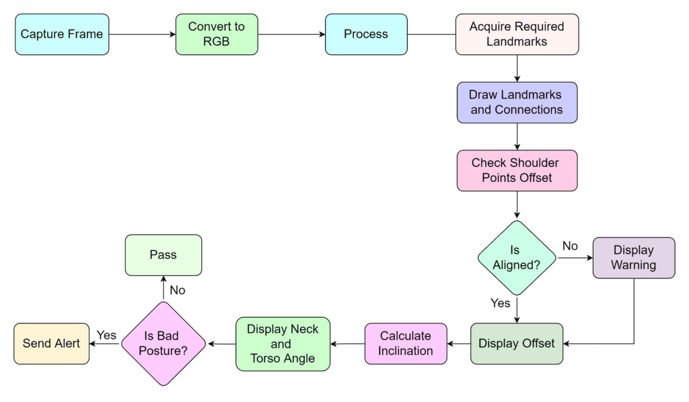

**OUTPUT AND SNAPSHOTS**

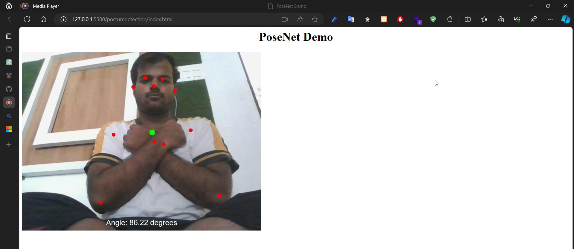

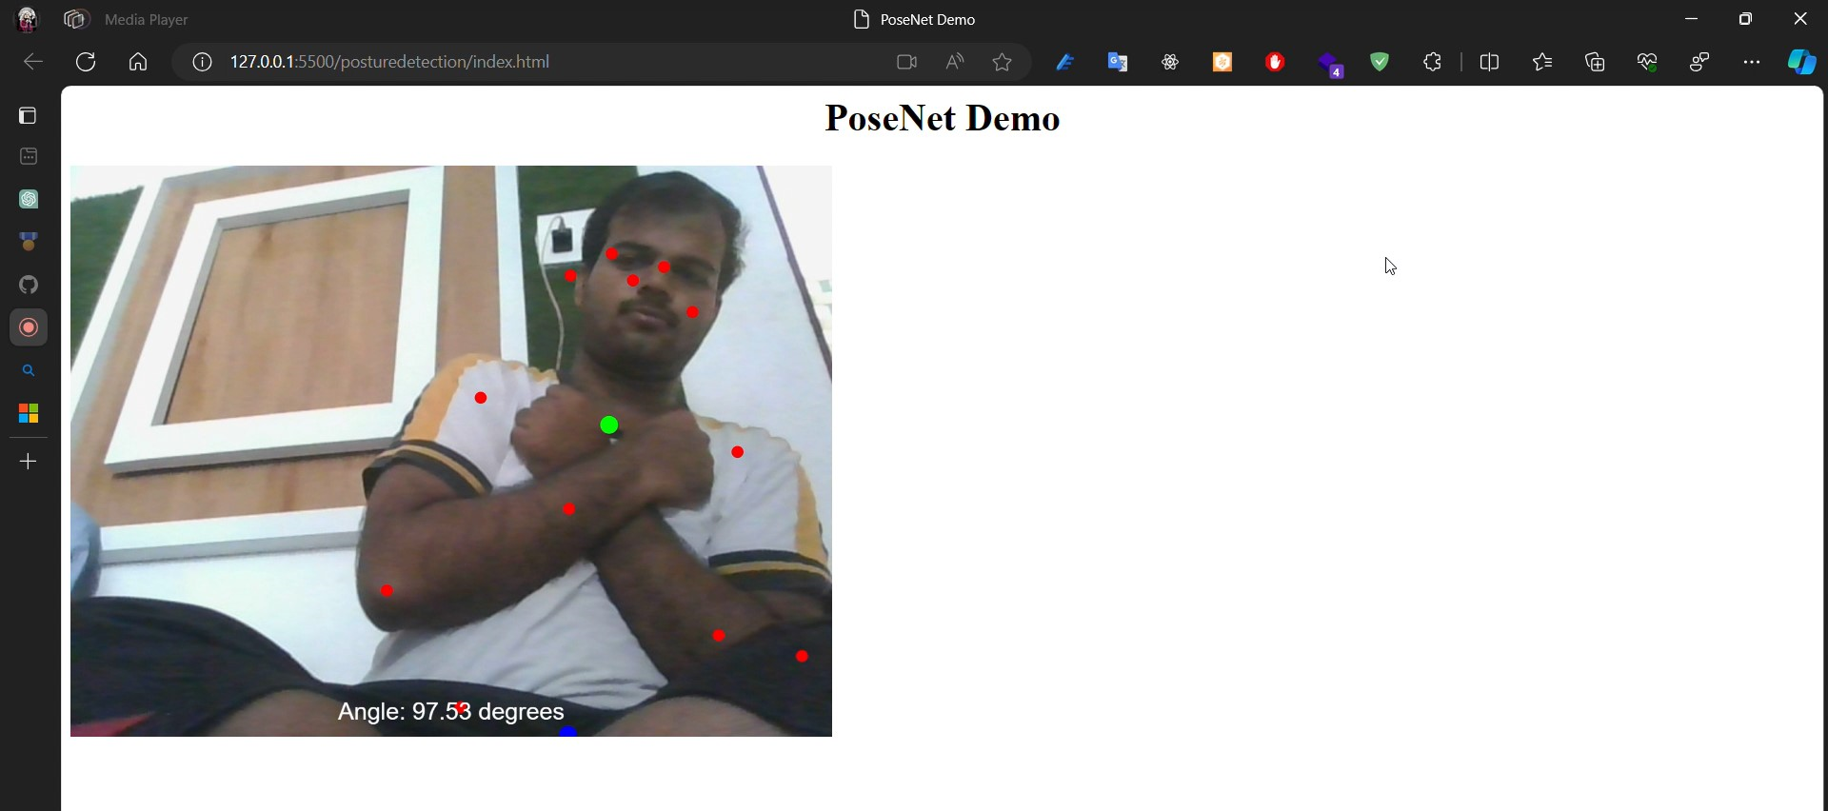

**CONCLUSION**

In conclusion, the developed posture analysis tool leveraging Pose Detection and PoseNet technology stands as a pivotal advancement in the domain of ataxia diagnosis and monitoring. By meticulously analyzing key body points, including shoulders, hips, knees, and ankles, deviations from standard postures indicative of ataxia disorders are accurately detected and assessed. The real-time coordination provided by Pose Detection Libraries, especially PoseNet, empowers precise tracking and analysis of user posture frame by frame. Through complex data analysis, encompassing angles between joints, the tool achieves a nuanced understanding of ataxia-related posture irregularities. The integration of user-friendly interfaces ensures accessibility, allowing seamless initiation and termination of analyses. Furthermore, the system's ability to provide instantaneous visual feedback and alerts regarding deviations enhances its clinical utility.

This tool not only bridges gaps in ataxia diagnosis by enabling remote assessments but also holds promise in advancing the accessibility and accuracy of neurological disorder diagnostics. Its effectiveness in capturing diverse gait characteristics and associating them with ataxia severity, as validated by feature importance analysis, underscores its clinical relevance. Ultimately, this innovative tool represents a substantial step toward improving the lives of individuals afflicted with ataxia, offering a sophisticated, real-time, and user-friendly solution in the realm of neurological disorder diagnosis and rehabilitation.

**REFERENCES**

1. Rahman, Wasifur et al. “Auto-Gait.” *Proceedings of the ACM on Interactive, Mobile, Wearable and Ubiquitous Technologies* 7 (2022): 1 - 19.
2. A. Kendall, M. Grimes and R. Cipolla, "PoseNet: A Convolutional Network for Real-Time 6-DOF Camera Delocalization," *2015 IEEE International Conference on Computer Vision (ICCV)*, Santiago, Chile, 2015, pp. 2938-2946, doi: 10.1109/ICCV.2015.336.
3. TensorFlow.js. "PoseNet: Pose Estimation in the Browser with TensorFlow.js." GitHub Repository. Available at: <https://github.com/tensorflow/tfjs-models/tree/master/posenet>.
4. The article titled "PoseNet: Your Gateway to Gesture Detection" published on Medium explores Pose estimation techniques in computer vision, focusing on real-time analysis of user poses. Source: <https://medium.com/globant/posenet-your-gateway-to-gesture-detection-a15d0ed0ae40#:~:text=Pose%20estimation%20refers%20to%20computer%20vision%20techniques%20that,the%20pose%20of%20a%20user%20in%20real%20time>.